

Focus EInvoice Plus

User Manual

Ver 1.01

Table of Contents

Installation and Registration 3

Registration (for the service) 4

Logging into the Application 6

Profile Menu 8

Dashboard 9

GSTIN wise dashboard Display 10

Settings Menu 11

Profile Settings Menu 11

GSTIN Menu 12

Editing a GSTIN 12

Deleting a GSTIN 12

Adding a GSTIN 12

Preferences Menu 14

Generation type 14

Manual 14

Auto 14

Instant Mode 15

On Time Mode 15

‘Every .. Minutes’ Mode 15

Import Type and Export Type 15

Excel 15

JSON 15

CSV File 15

‘File From’ / File path 16

Template Mapping and Default Template 17

E-Invoice fields explanation 18

E-Invoice Menu 30

Generate E-Invoices Tile 31

Imported Data Review 32

‘Valid Invoices’ Tab 32

‘Not Valid Invoices’ Tab 33

Proposed Action: 33

‘Already E-Invoice generated’ Tab 34

View All Invoices Tile 35

Viewing an E-Invoice/Eway Bill Generated 35

Cancelling an E-Invoice/EWay Bill 35

Printing an E-Invoice/EWay Bill 35

Export to Excel 35

Validations 36

Validations for E-Invoices 36

Validations on Items: 38

Calculation of Values: 38

Validations on e-waybill: 40

Data Import History Tile 42

Role Management Menu 43

Creating a Role 44

Editing Roles 44

User Management 45

User Creation 46

Disabling User 46

Editing User 46

# Installation and Registration

Download the Application and Run the application

The Login Page is displayed. Screenshot shown below.

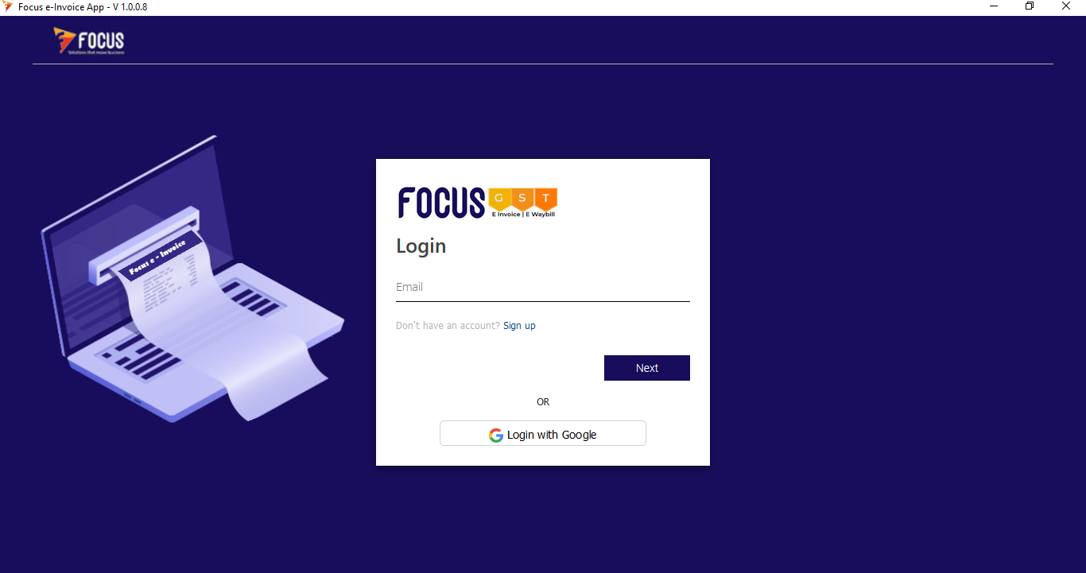

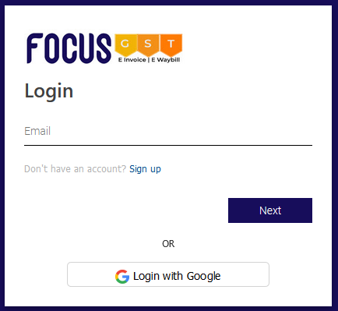

## Registration (for the service)

If not already registered

* Click on ‘Sign up using Google’ if you want to use your existing Google Account Credentials.
* Alternately, to create credentials form other mailboxes, click on the ‘Signup’ button

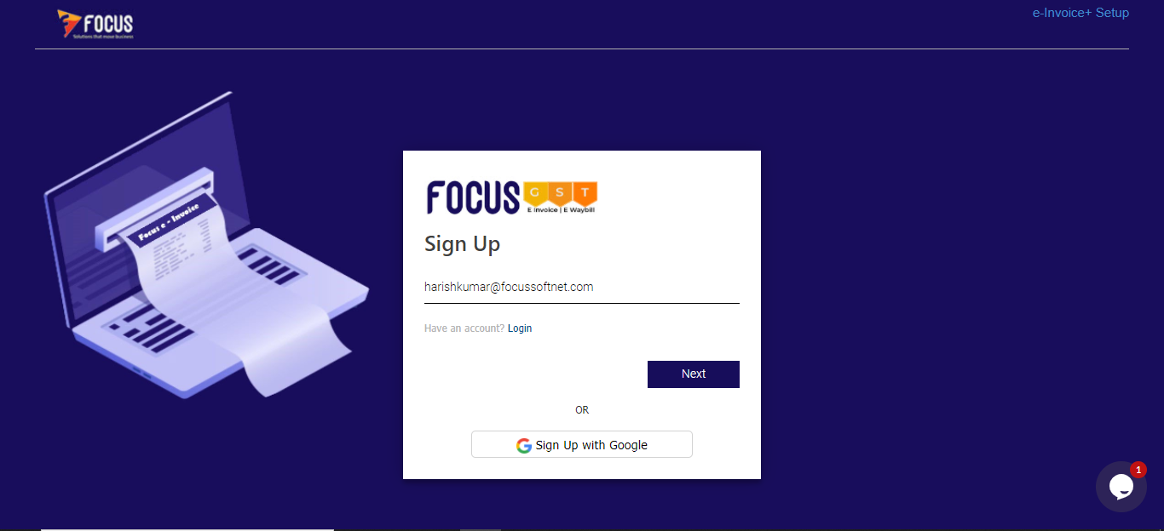

Provide your eMail ID and click on ‘Next’

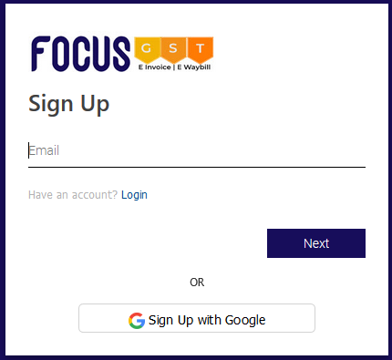

Enter desired password for the login and click on ‘Sign Up’.



Enter the 6-character Verification code sent to the registered email and click on ‘Verify’.

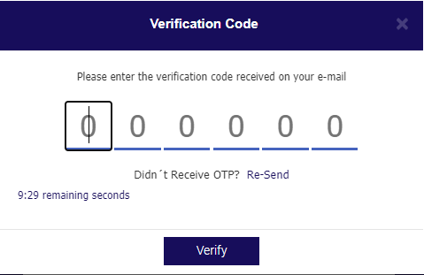

On successful verification, you will be logged into the application.

# Logging into the Application

The Application is available for use only for registered emails. If not already registered, please register for the service as explained in the earlier section

Run the Application.

The Login screen is shown to you.

If you have registered using Google Account, you can use the ‘Login with Google’ button.

Provide registered email and click on ‘Next’.

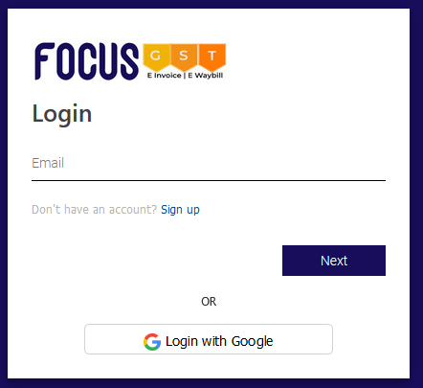

Enter Password and click on ‘Sign in’ button



# Profile Menu

On successful Login, you are shown the ‘Profile’ pop up in which you need to provide details. These details can be revisited anytime in the Settings > Profile menu

Note: Throughout the application, any field that is mandatory is highlighted with a red strip.

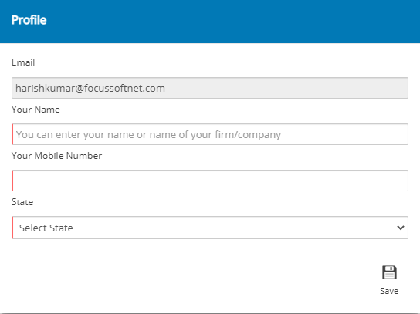

* Provide details required and click on ‘Save’.

## Dashboard

The ‘Dashboard’ is displayed as shown below

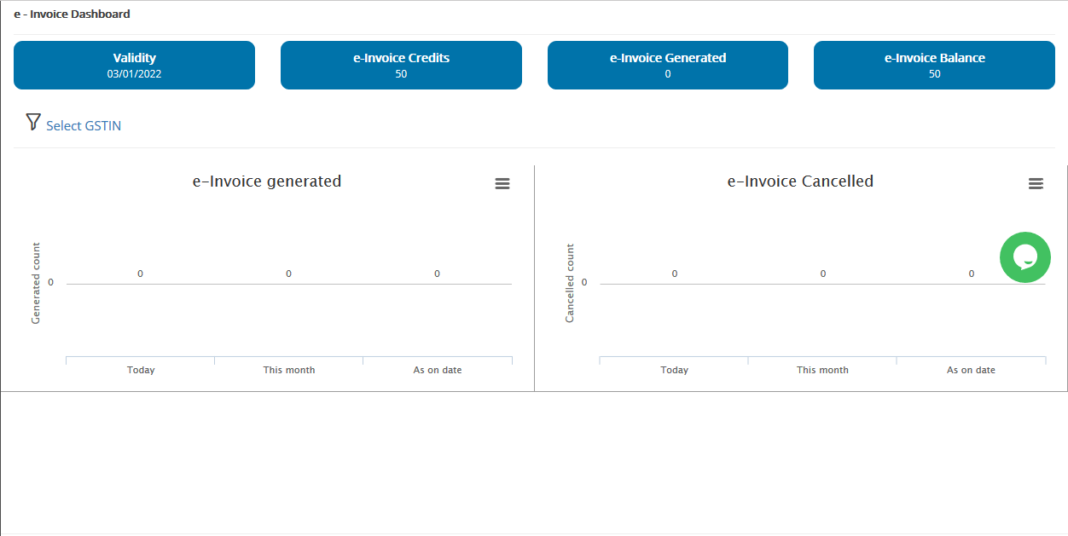

The dashboard shows details like

* Validity date
* E-Invoice Credits
* E-Invoices Generated
* E-Invoices Cancelled and

Graphical representation of the E-Invoices generated and E-Invoices cancelled as on today, as for the month and total is also displayed.

### GSTIN wise dashboard Display

For GSTIN wise displays on dashboard, click on the ‘Select GSTIN’ button on the screen and select the GSTIN for which you need to view details and the dashboard will refresh

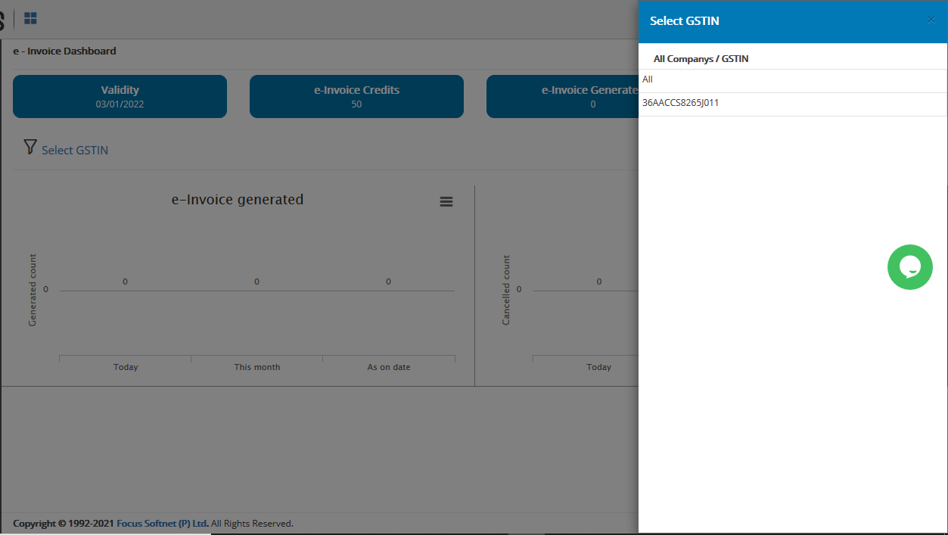

# Settings Menu

## Profile Settings Menu

* Go to ‘Settings > Profile’ menu

Company Registration details are shown here

User can change the Name and the Mobile Number fields.

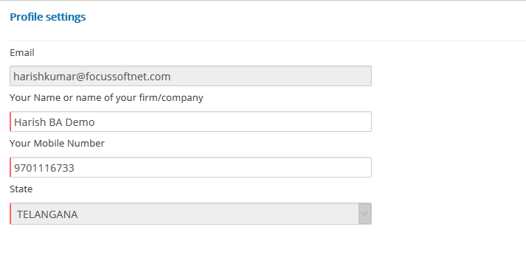

## GSTIN Menu

* Go to ‘Settings > GSTIN’ menu to view the list of GSTINs using which the user will be generating E-Invoices.

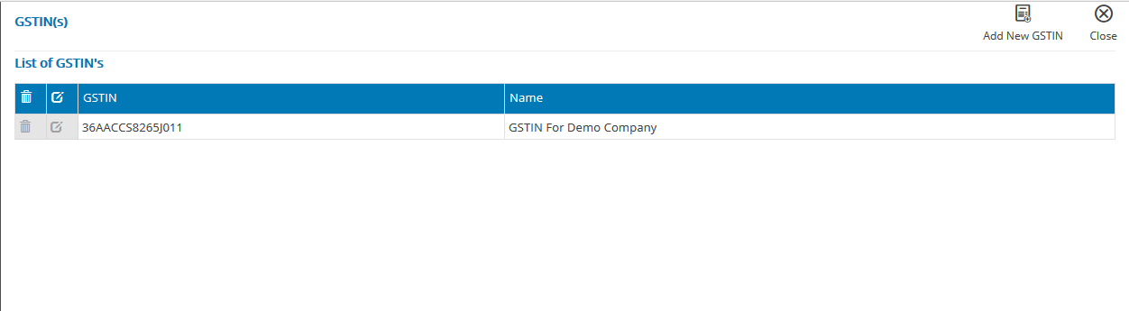

### Editing a GSTIN

To modify/make changes to an existing GSTIN, use the Edit Button provided against the GSTIN in the grid. Make changes and click on Save Button.

### Deleting a GSTIN

To delete an existing GSTIN, use the Delete Button provided against the GSTIN in the grid

### Adding a GSTIN

To add other GSTINs, use the ‘Add New GSTIN’ button in the GSTIN Menu.

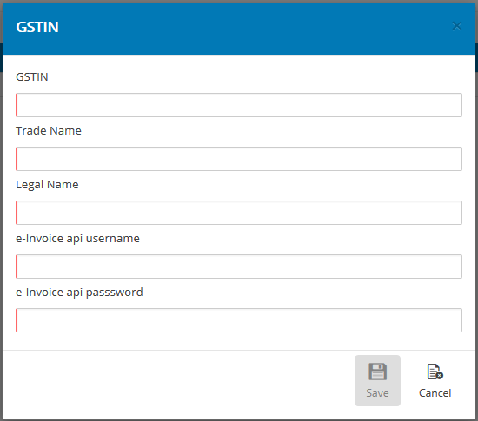

* Provide necessary details in the pop up and click on the ‘Save’ button.

## Preferences Menu

* Go to ‘Settings > Preferences’

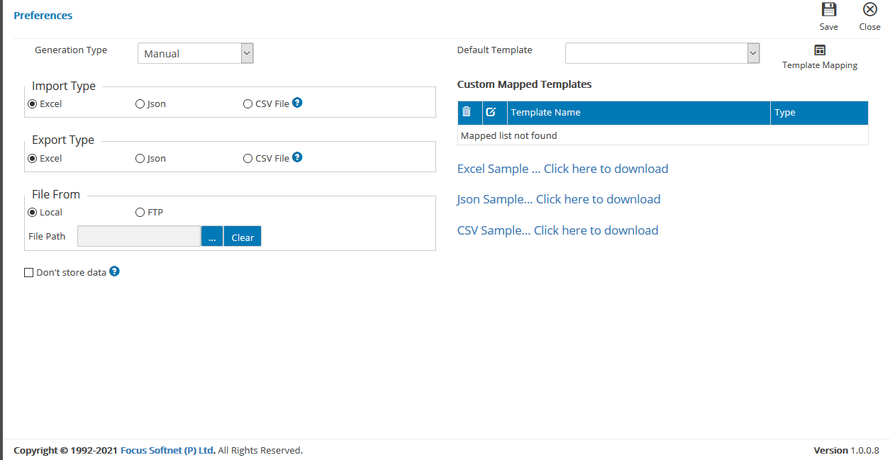

Set preferences for Application usage as explained below

### Generation type

This specifies how the user desires the application to generate E-Invoices. It can be set to Manual’ or ‘Auto’.

#### Manual

* E-Invoices will be generated only when user provides data and clicks on the buttons at each level (as will be described in the document.)

#### Auto

* E-Invoices will be generated based on User preferences.

When user selects ‘Auto’ Generation Type, the following options are displayed for user selection.

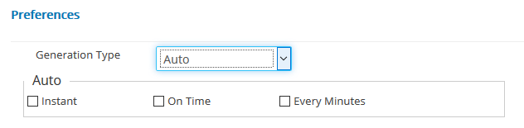

##### Instant Mode

* ‘Instant’ mode in which the application will look for new files in the set location and generate an E-Invoice as and when a new file is found in the location.

##### On Time Mode

* ‘On Time’ mode is set when user wants to generate E-Invoices for all invoices in the folder at a specific time, once a day. User will need to specify the time when he wants the application to generate E-Invoices

##### ‘Every .. Minutes’ Mode

* ‘Every Minutes’ mode when user wants the application to generate E-Invoices after a defined interval of time. In this case, as mentioned by the user, after the set interval of time, the application will look for new files in the folder and generate E-Invoices for them.

### Import Type and Export Type

The Application allows import and export in Excel, JSON and CSV formats. User will be required to specify choice of format of preference.

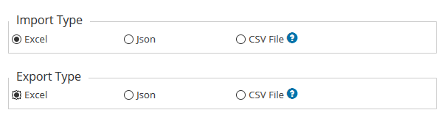

#### Excel

* User will provide details of the vouchers for Einvoicing in an Excel format

#### JSON

* User must provide details of the vouchers for Einvoicing in valid JSON formats

#### CSV File

* User will provide details of the vouchers for Einvoicing in valid CSV file formats

When user selects ‘CSV File’, the application seeks the user preference for delimiters that will be used in the CSV files. User will provide choice in the textbox displayed.

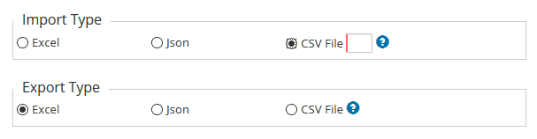

Note: For CSV format, valid delimiters are Tilda ( ~ ), Comma( , ) and Circumflex ( ^ ). Usage of other characters as delimiters will result in error response.

Sample files for each of these formats is provided for download on the page. Users can download these formats and use them for providing invoice details for EInvoicing.

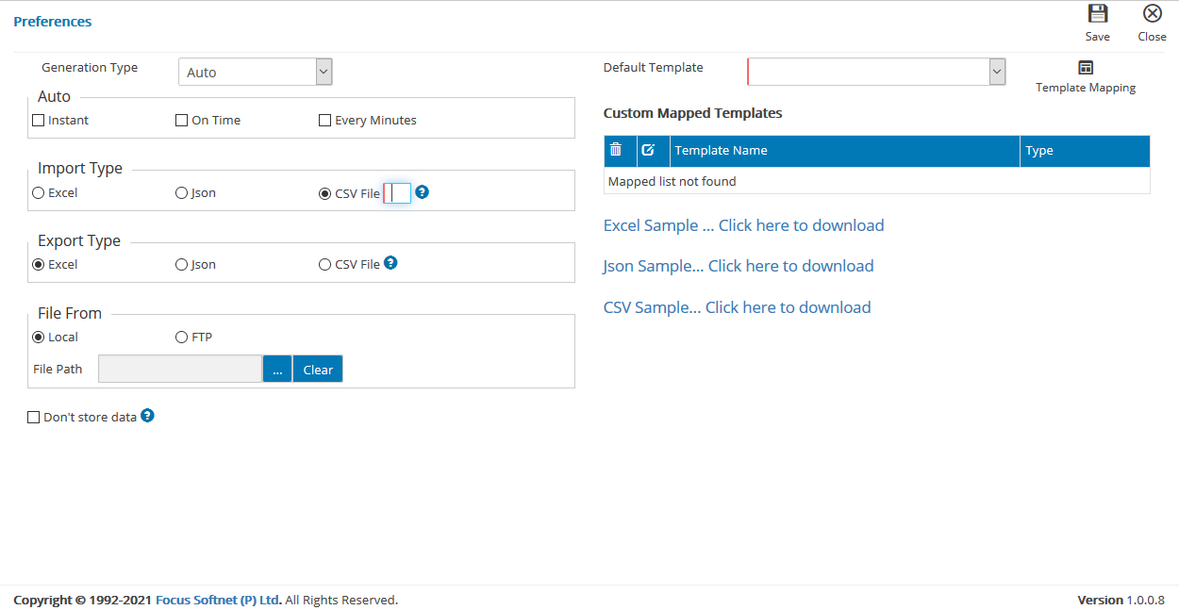

### ‘File From’ / File path

In the ‘File From’ section, the user will be required to specify the File access details like Local Path or the FTP Path (along with IP and the File Name) in combination with the User Name and Password.

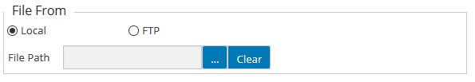

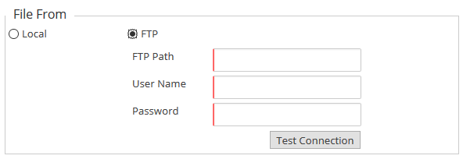

* If Generation Type is set to ‘Auto’, user must set this definite as the Application will look for new files to generate E-Invoices in the preset location.
* For ‘Manual’ Generation Mode, the application will look for for new files to generate E-Invoices in the preset location. If such a location is not set in ‘Preferences’, the application will prompt user for each instance (will be explained later in this document).

### Template Mapping and Default Template



Users can use the ‘Template Mapping’ button to map fields in their own template for each of the mandatory E-Invoice fields.

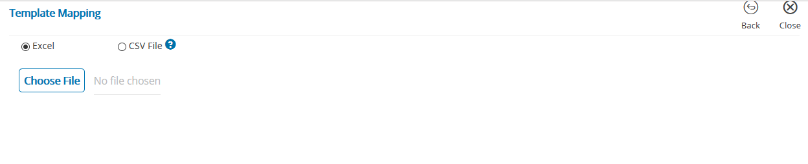

* Select the format of the file
* Click on ‘Choose File’ to navigate to the location of the file available at user end. Select the file.

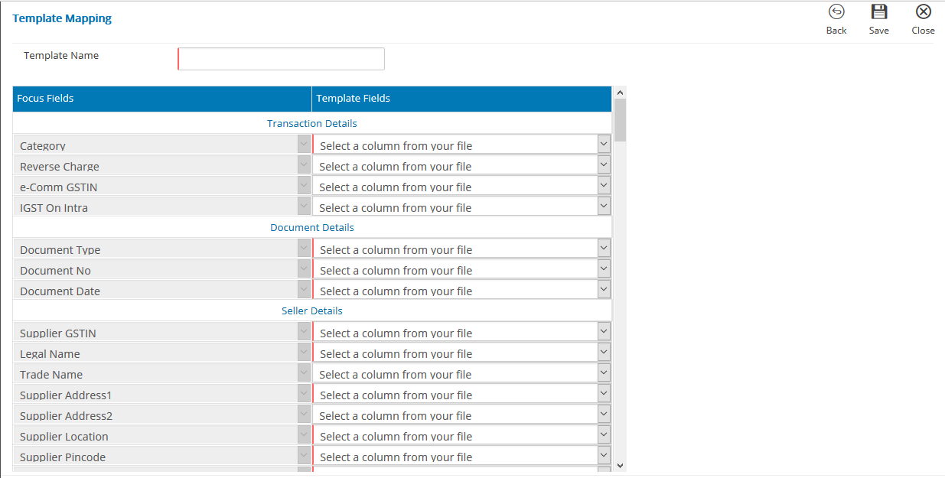

* Against each E-Invoice field in the first column, select the relevant field in the user’s custom template. Click on Save after mapping the fields.

Note: When custom templates are used, the data in the fields mapped against an E-Invoice field are validated for relevant validations.

Note: Fields with a red strip are mandatory fields for successful eInvoicing. All such fields need to be mapped to save Field Mapping

#### E-Invoice fields explanation

Table 1

|  |  |  |  |  |  |
| --- | --- | --- | --- | --- | --- |
|  |  |  |  |  |  |
|  | S No | E-Invoice field | Description | Remarks |  |
|  | 1 | Category | Code to identify type of supply | ENums : |  |
|  | B2B-Business to Business |  |
|  | SEZWP - SEZ with payment |  |
|  | SEZWOP - SEZ without payment |  |
|  | EXPWP - Export with Payment |  |
|  | EXPWOP - Export without payment |  |
|  | DEXP - Deemed Export |  |
|  | 2 | Reverse Charge | Is the tax liability payable under reverse charge? | ENums: Y,N Y-Yes N-No |  |
|  | 3 | e-Comm GSTIN | Mention GSTIN of E commerce operator (only if supply is made through Ecommerce Operator) | Validation: Valid GSTIN only is accepted. Length 15 |  |
|  | In case of e-commerce transactions, the e-Commerce Operator can request for the IRN/e-invoice on behalf of the supplier. In this case, the e-Commerce Operator should have been registered on the GST portal as e-Commerce Operator and pass eCom_GSTIN accordingly. |  |
|  | 4 | IGST On Intra | Is the supply liable to IGST even if the Supplier and Recipient are located within same State/UT? | ENums: Y,N Y-Yes N-No |  |
|  | 5 | Document Type | Specify Type of the Document . | Mandatory field  ENums: |  |
|  | INV (Invoice) |  |
|  | CRN (Credit Note and Sales Return) |  |
|  | DBN (Debit Note) |  |
|  | 6 | Document No | Invoice Number | Mandatory field  Min Length: 1 |  |
|  | "pattern": "^([a-zA-Z1-9]{1}[a-zA-Z0-9\/-]{0,15})$" | Max length:16 |  |
|  | Document number should not be starting with 0, / and -. | String |  |
|  | 7 | Document Date | The date when the Invoice was issued | Mandatory field  Format: "DD/MM/YYYY" |  |
|  |  |
|  | 8 | Supplier GSTIN | GSTIN of the Supplier | Mandatory field  Validation: Valid GSTIN only is accepted. |  |
|  | Length 15 |  |
|  | Alphanumeric |  |
|  | 9 | Legal Name | Legal Name as appearing in PAN of the Supplier | Mandatory field  Min Length:3 Max length:100 |  |
|  | String |  |
|  | 10 | Trade Name | Business name of the supplier | Min Length:3 Max length:100 |  |
|  | String |  |
|  | 11 | Supplier Address1 | Address of the Supplier | Mandatory field  Min Length:1 Max length:100 |  |
|  | 12 | Supplier Address2 | Address line 2 | Min Length:3 Max length:100 |  |
|  | 13 | Supplier Location | City/Town/Village of the Supplier | Mandatory field  Min Length:3 Max length:50 |  |
|  | 14 | Supplier Pincode | Pincode of the Supplier | Mandatory field  Fixed length:6 Min : 100000 Max: 999999 Refer to masters on the Einvoice Portal. https://einvoice1.gst.gov.in/Others/MasterCodes |  |
|  | 15 | Supplier State | StateCode of the Supplier | Mandatory field  Min Length:1 Max Length:2 |  |
|  | Only Valid State Codes are acepted. Refer Masters on EInvoice Portal https://einvoice1.gst.gov.in/Others/MasterCodes |  |
|  | 16 | Supplier Phone Number | Contact number of the Supplier | Min Length:6 Max length:12 |  |
|  | 17 | Supplier Email ID | Email id of the Supplier. | Min Length:6 Max length:100 |  |
|  | 18 | Customer GSTIN | GSTIN of the Buyer | Mandatory field  Validation: Valid GSTIN Only. Send 'URP' in case of unregistered person/export |  |
|  | Min Length :3 Max Length: 15 |  |
|  | Alphanumeric |  |
|  | Mention ‘URP’, In case of exports or if supplies are made to unregistered persons |  |
|  | 19 | Customer Legal Name | Legal name of buyer | Mandatory field  Min Length: 3 Max length:100 |  |
|  | String |  |
|  | 20 | Customer Trade Name | Trade Name of buyer | Min Length: 3 Max length:100 |  |
|  | String |  |
|  | 21 | Customer Place of Supply | Place of supply code of Supply | Mandatory field  Valid State Codes only. Refer to Masters on EInvoice Portal  https://einvoice1.gst.gov.in/Others/MasterCodes |  |
|  | Min Length : 1 Max length:2 |  |
|  | 22 | Customer Address1 | Address 1 of the Buyer | Mandatory field  Min Length : 1 Max length:100 |  |
|  | 23 | Customer Address2 | Address 2 of the Buyer | Min Length : 3 Max length:100 |  |
|  | 24 | Customer Location | City/Town/Village of the Buyer | Mandatory field  Min Length : 3 Max length:100 |  |
|  | 25 | Customer Pin Code | Pincode of the Buyer | Mandatory field  Max length:6 |  |
|  | In case of export, Pincode 999999 need to be mentioned. Refer to masters on the Einvoice Portal. https://einvoice1.gst.gov.in/Others/MasterCodes |  |
|  | 26 | Customer State | State of the Buyer | Mandatory field  Valid State Codes only  Refer to Masters on EInvoice Portal https://einvoice1.gst.gov.in/Others/MasterCodes |  |
|  | Min Length: 1 Max length:2 |  |
|  | 27 | Customer Phone Number | Contact Number of the Buyer | Min Length : 6 Max length:12 |  |
|  | 28 | Customer Email Id | Email id of the buyer. | Min Length : 6 Max length:100 |  |
|  | 29 | Dispatch Legal Name | Name of the entity from where goods are dispatched | Min Length : 3 Max length:100 |  |
|  | 30 | Dispatch Address1 | address wherefrom goods are dispatched. | Min Length : 1 Max length:100 |  |
|  | 31 | Dispatch Address2 | address wherefrom goods are dispatched. | Min Length : 3 Max length:100 |  |
|  | 32 | Dispatch Location | City/Town/Village wherefrom goods are dispatched. | Min Length : 3 Max length:100 |  |
|  | 33 | Dispatch Pin Code | Pincode wherefrom goods are dispatched. | Length:6 Refer to masters on the Einvoice Portal. https://einvoice1.gst.gov.in/Others/MasterCodes |  |
|  | 34 | Dispatch State | State wherefrom goods are dispatched. | Valid State Codes only. Refer to masters on the Einvoice Portal. https://einvoice1.gst.gov.in/Others/MasterCodes |  |
|  | Min Length :1 Max length:2 |  |
|  | 35 | Shipping GSTIN | GSTIN of the person to which goods and services invoiced are delivered | Validation: Valid GSTIN Only |  |
|  | Max Length: 15 |  |
|  | Alphanumeric |  |
|  | 36 | Shipping Legal Name | Legal Name of the entity to whom the supplies are shipped to. | Min Length : 3 Max length:100 |  |
|  | 37 | Shipping Trade Name | Trade Name of the entity to whom the supplies are shipped to. | Min Length : 3 Max length:100 |  |
|  | 38 | Shipping Address1 | Address to which goods and services invoiced are Shipped to | Min Length : 1 Max length:100 |  |
|  | 39 | Shipping Address2 | Address to which goods and services invoiced are shipped to | Min Length : 3 Max length:100 |  |
|  | 40 | Shipping Location | City/Town/Village of the address to which goods and services invoiced are shipped to | Min Length : 3 Max length:100 |  |
|  | 41 | Shipping Pin Code | Pincode of the address to which goods and services invoiced are shipped to | Length:6 Refer to masters on the Einvoice Portal. https://einvoice1.gst.gov.in/Others/MasterCodes |  |
|  | 42 | Shipping State | State of the address to which goods and services invoiced are shipped to | Valid State Codes only. Refer to masters on the Einvoice Portal. <https://einvoice1.gst.gov.in/Others/MasterCodes> |  |
|  | Min Length : 1 Max length:2 |  |
|  | 43 | Sl.No. | Serial No of the invoiced item | Mandatory field  Min length :1 Max length:6 |  |
|  | String |  |
|  | 44 | Product Description | Description of the item | Min Length:3 Max length:300 |  |
|  | String |  |
|  | 45 | Is Service | Specify whether supply is that of Services or not | Mandatory field  ENums : Y,N  Y-Yes N-No |  |
|  | 46 | HSN | A HSN/SAC code for classifying the item by its type or nature. | Mandatory field  Min Length: 4 Max length:8 |  |
|  | String.  Only valid HSN Codes need to be provided. HSN of Length (4 or 6 or 8) as applicable for your turnover needs to be used. Refer to masters on the Einvoice Portal. [https://einvoice1.gst.gov.in/Others/MasterCodes](https://einvoice1.gst.gov.in/Others/MasterCodes%20) |  |
|  | 47 | Bar code | Barcode if any, need to be specified | Min Length: 3 |  |
|  | Max length:30 |  |
|  | String |  |
|  | 48 | Quantity | The quantity of items (goods or services) that is charged in the Invoice line. | Mandatory field  Number |  |
|  | Minimum: 0 |  |
|  | Maximum: 9999999999.999 |  |
|  | 49 | Free Qty | Detail of any item given ‘Free Of Charge’ | Number |  |
|  | Minimum: 0 |  |
|  | Maximum: 9999999999.999 |  |
|  | 50 | Unit | The unit of measure that applies to the invoiced quantity. | Mandatory field  String |  |
|  | Minimum Length: 3 |  |
|  | Maximum Length: 8 |  |
|  | Only Valid Unit Master codes are accepted. Refer to masters on the Einvoice Portal. <https://einvoice1.gst.gov.in/Others/MasterCodes> |  |
|  | 51 | Unit Price | Price per unit item. | Mandatory field  Number  Minimum:0 Maximum: 999999999999.999 |  |
|  | 52 | Gross Amt | The gross price of an item (cost multiplied by quantity - rounded off to 2 decimal), exclusive of taxes. | Mandatory field  Number  Minimum:0 Maximum: 999999999999.99 Calculate as (Unit Price * Quantity) |  |
|  | 53 | Discount | The discount given for the item in the invoice line | Number  Minimum:0 Maximum: 999999999999.99 |  |
|  | 54 | Pre Tax Value | In some cases, the pre-tax value may be different from taxable value. If pre-tax value is different from taxable value, mention the pre-tax value and taxable values separately. | Number  Minimum:0 Maximum: 999999999999.99 |  |
|  | 55 | Taxable value | Taxable Value of the invoiced item line. Cannot be negative. | Mandatory field  Number  Minimum:0 Maximum: 999999999999.99 Calculate as (Gross Amount - Discount) |  |
|  | 56 | GST Rate(%) | The GST rate, (without percentage sign) that applies to the invoiced item. | Mandatory field  Number  Minimum:0 Maximum: 999.999 |  |
|  | 57 | IGST Value | IGST Amount for the invoice line | Number  Minimum:0 Maximum: 999999999999.99 |  |
|  | 58 | CGST Value | CGST Amount for the invoice line | Number  Minimum:0 Maximum: 999999999999.99 |  |
|  | 59 | SGST Value | SGST Amount for the invoice line | Number  Minimum:0 Maximum: 999999999999.99 |  |
|  | 60 | Cess Rate(%) | Cess Rate Ad Valorem | Number  Minimum:0 Maximum: 999.999 |  |
|  | 61 | Cess Value | CESS Ad Valorem Amount as per item. Arrived on basis of rate and quantity of item | Number  Minimum:0 Maximum: 999999999999.99 |  |
|  | 62 | Cess Non Ad Value | Cess non Ad valorem Amount | Number  Minimum:0 Maximum: 999999999999.99 |  |
|  | 63 | State Cess(%) | State Cess rate Ad Valorem | Number  Minimum:0 Maximum: 999.999 |  |
|  | 64 | State Cess Value | State CESS Ad Valorem Amount as per item | Number  Minimum:0 Maximum: 999999999999.99 |  |
|  | 65 | State Cess Non Ad Value | State Cess non Ad valorem Amount | Number  Minimum:0 Maximum: 999999999999.99 |  |
|  | 66 | Other Charges | Other Charges | Number  Minimum:0 Maximum: 999999999999.99 |  |
|  | 67 | Total Item Amount | Net Amount of the Item line inclusive of GST and Cess Amounts | Mandatory field  Number  Minimum:0 Maximum: 999999999999.99 Calculate as Total Item Amount = Taxable Value + IGST Value + CGST Value + SGST Value + Cess Value + Cess Non Ad Value + State Cess Value + State Cess Non Ad value + Other Charges |  |
|  | 68 | Order line Reference | Reference to purchase order | Min Length:1 Max length:50 |  |
|  | String |  |
|  | 69 | Origin Country | Origin country of item | Length:2 |  |
|  | String Valid Country Codes to be used. Refer to masters on the Einvoice Portal. <https://einvoice1.gst.gov.in/Others/MasterCodes> |  |
|  | 70 | Item Unique Serial Number | Serial Number in case of each item having unique number. | Min Length:1 Max length:20 |  |
|  | String |  |
|  | 71 | Total Taxable Value | Sum of All Invoice Item line Taxable Amounts | Mandatory field  Number  Minimum:0 Maximum: 99999999999999.99 Calculate as Total of Taxable Value of all items |  |
|  | 72 | Total IGST Value | Sum of All Invoice Item line IGST Amounts | Number  Minimum:0 Maximum: 99999999999999.99 Calculate as Total of IGST Value of all items |  |
|  | 73 | Total CGST Value | Sum of All Invoice Item line CGST Amounts | Number  Minimum:0 Maximum: 99999999999999.99 Calculate as Total of CGST Value of all items |  |
|  | 74 | Total SGST Value | Sum of All Invoice Item line SGST Amounts | Number  Minimum:0 Maximum: 99999999999999.99 Calculate as Total of SGST Value of all items |  |
|  | 75 | Total Cess Amt | Sum of All Invoice Item line Cess Amounts | Number  Minimum:0 Maximum: 99999999999999.99 Calculate as Total of Cess Value of all items |  |
|  | 76 | Total State Cess Amt | Sum of All Invoice Item line State Cess Amounts | Number  Minimum:0 Maximum: 99999999999999.99 Calculate as Total of State Cess Value of all items |  |
|  | 77 | Invoice Discount | Total Discount Amount | Number  Minimum:0 Maximum: 99999999999999.99 |  |
|  | 78 | Invoice Other Charges | Total Value of allowances and charges at invoice level | Number  Minimum:0 Maximum: 99999999999999.99 |  |
|  | 79 | Invoice Round off | The amount to be added to the invoice total to round the amount to be paid. Must be rounded to maximum 2 decimals. | Number  Minimum:-99.99 Maximum: 99.99 |  |
|  | 80 | Invoice Value | The total amount of the Invoice with GST. Must be rounded to maximum 2 decimals. | Mandatory field  Number  Minimum:0 Maximum: 99999999999999.99 |  |
|  | 81 | Total Invoice Value in FCNR | The additional currency, if any, in which all invoice amounts are given, along with INR. | Number  Minimum:0 Maximum: 99999999999999.99 |  |
|  | 82 | Shipping Bill No | In case of export/supply to SEZ, shipping bill number as per Indian Customs EDI System (ICES) | Min Length:1 Max length:20 |  |
|  | String |  |
|  | 83 | Shipping Bill Dt | Date of Shipping Bill as per Indian Customs EDI System (ICES) | Format : DD/MM/YYYY |  |
|  |  |  |
|  | 84 | Port | In case of export/supply to SEZ, port code can be mentioned as per Indian Customs EDI System (ICES) | Min Length:2 Max length:10 Only Valid port codes are accepted. Refer to masters on the Einvoice Portal. <https://einvoice1.gst.gov.in/Others/MasterCodes> |  |
|  | 85 | Refund claim | In case of deemed export supplies, this field is for mentioning whether supplier can exercise the option of claiming refund or not. | ENums: Y,N Y-Yes N-No |  |
|  | 86 | Foreign Currency | The additional currency, if any, in which all invoice amounts can be given, along with INR. | Min Length:3 Max length:16 Valid codes are accepted. Refer to masters on the Einvoice Portal. <https://einvoice1.gst.gov.in/Others/MasterCodes> |  |
|  | 87 | Country Code of Export | Code of country of export as per ISO 3166-1 alpha-2 / Indian Customs EDI system | Length: 2 Valid codes are accepted. Refer to masters on the Einvoice Portal. <https://einvoice1.gst.gov.in/Others/MasterCodes> |  |
|  | 88 | Export Duty Amount | Amount of Export Duty in INR, if any, applicable (in case of invoices for export) | Number  Minimum:0 Maximum: 999999999999.99 |  |
|  | 89 | Trans ID | Transporter ID | Max length:15 |  |
|  | String |  |
|  | 90 | Trans Name | Transporter Name | Min Length:3 Max length:100 |  |
|  | String |  |
|  | 91 | Trans Mode | Mode of transportation | Enums : 1,2,3,4, NA 1 (Road) |  |
|  | 2 (Rail |  |
|  | 3 (Air) |  |
|  | 4 (Ship)  NA – when selected, Eway Bill will not be generated |  |
|  | 92 | Distance | Distance of transportation | Minimum:0 Maximum:4000 Max Length : 4 |  |
|  | 93 | Trans Doc No | Transporter Doc No | Mandatory if the mode of transport is other than by Road Min length:1 Max length:15 |  |
|  | 94 | Trans Doc Date | Transporter Doc Date | string (DD/MM/YYYY) |  |
|  | 95 | Vehicle No. | Vehicle Registration No | Min Length: 4 Max length:20 |  |
|  | String |  |
|  | 96 | Vehicle Type | Vehicle Type | ENums: O, R |  |
|  | Overdimensional, Regular |  |
|  | 97 | Payee Name | Name of the person to whom payment is to be made | Min Length :1 Max length:100 |  |
|  | String |  |
|  | 98 | Account Number | Account number of Payee | Min Length :1 Max length:18 |  |
|  | String |  |
|  | 99 | Mode | Payment mode | Min Length :1 Max length:18 |  |
|  | ENums : Cash, Credit, Direct Transfer, etc |  |
|  | 100 | Branch/IFSC Code | IFSC of Bank Branch of Payee | Min Length :1 Max length:11 |  |
|  | String |  |
|  | 101 | Term of payment | Terms of Payment with the recipient if to be provided | Min Length :1 Max length:100 |  |
|  | String |  |
|  | 102 | Payment Instruction | Payment Instruction | Min Length :1 Max length:100 |  |
|  | String |  |
|  | 103 | Credit Transfer | specify credit transfer payments. | Min Length :1 Max length:100 |  |
|  | String |  |
|  | 104 | Direct Debit | specify direct debit terms. | Min Length :1 Max length:100 |  |
|  | String |  |
|  | 105 | Credit Days | The date when the payment is due. | Min:0 Max:9999 |  |
|  | 106 | Payment Received | The amount paid in advance. It must be rounded to maximum 2 decimals. | Number  Minimum:0 Maximum: 99999999999999.99 |  |
|  | 107 | Payment Date | The date when the payment is due. Cant find this field in the Schema Excel. | Format "DD/MM/YYYY". |  |
|  | 108 | Balance Amount | The outstanding amount due for payment. It must be rounded to maximum 2 decimals | Number  Minimum:0 Maximum: 99999999999999.99 |  |
|  | 109 | Remarks | A textual note that gives unstructured information that is relevant to the Invoice as a whole.Such as the reason for any correction or assignment note in case the invoice has been factored. | Max length:100 Min Length: 3 |  |
|  | String |  |
|  | 110 | Invoice Period Start Date | Invoice period start date | Format "DD/MM/YYYY". |  |
|  | 111 | Invoice Period End Date | Invoice period end date | Format "DD/MM/YYYY". |  |
|  | 112 | Original Invoice | reference of original invoice( to be provided only in the case of debit and credit notes. | Min Length:1 Max length:16 |  |
|  | String |  |
|  | 113 | Preceding Invoice Date | Date of Preceeding Invoice | Format "DD/MM/YYYY". |  |
|  | 114 | Other Refernce | Provide any additional reference | Min Length:1 Max length:20 |  |
|  | String |  |
|  | 115 | Receipt Advice Number | Number of the receipt advice to the customer, in lieu of advance. | Min Length:1 Max length:20 |  |
|  | String |  |
|  | 116 | Date of Receipt Advice | Date of issue of receipt advice for advance. | Format "DD/MM/YYYY". |  |
|  | 117 | Lot/Batch Reference Number | Lot / Batch Reference | Min Length:1 Max length:20 |  |
|  | String |  |
|  | 118 | Contract Reference Number | Contract Number | Min Length:1 Max length:20 |  |
|  | String |  |
|  | 119 | Any other reference | Any additional reference number for such supply. | Min Length:1 Max length:20 |  |
|  | String |  |
|  | 120 | Project Reference Number | Project number if supplies are made under any specific Project | Min Length:1 Max length:20 |  |
|  | String |  |
|  | 121 | Vendor Po Reference Number | Vendor PO Reference number | Min Length:1 Max length:16 |  |
|  | String |  |
|  | 122 | Vendor PO Reference Date | Vendor PO Reference date | Format "DD/MM/YYYY". |  |
|  | 123 | Supporting Doc URL | additional supporting documents substantiating the claims made in the Invoice. | Min Length:3 Max length:100 |  |
|  | String |  |
|  | 124 | Supporting Doc in Base 64 format | additional supporting documents substantiating the claims made in the Invoice. | Min Length:3 Max length:1000 |  |
|  | String |  |
|  | 125 | Any additional Information | Any additional information that is specific for the Supplier-Recipient transaction | Min Length:3 Max length:1000 |  |
|  | String |  |
|  |  |  |  |  |  |

Wherein the user has multiple formats at his disposal, he can use the ‘Default Template’ dropdown to select an existing Excel/CSV format used by them as a default format for the EInvoicing input filed.

Note: Providing Input file in a file different from the set default template may result in errors while generating E-Invoices.

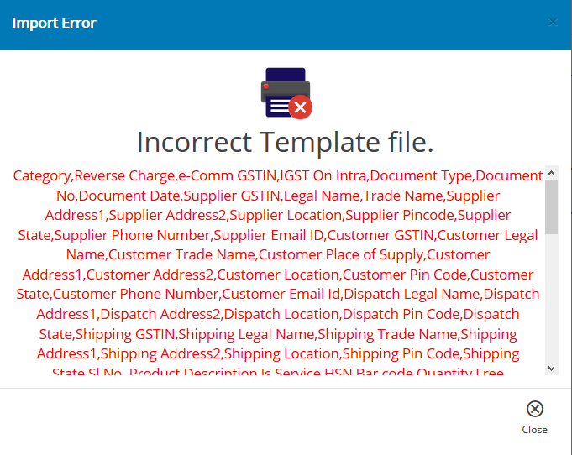

So, whenever the user wants to shuffle between the formats, he needs to set the desirable format for providing input files as the default template.

# E-Invoice Menu

* Go to ‘Settings > E-Invoice’

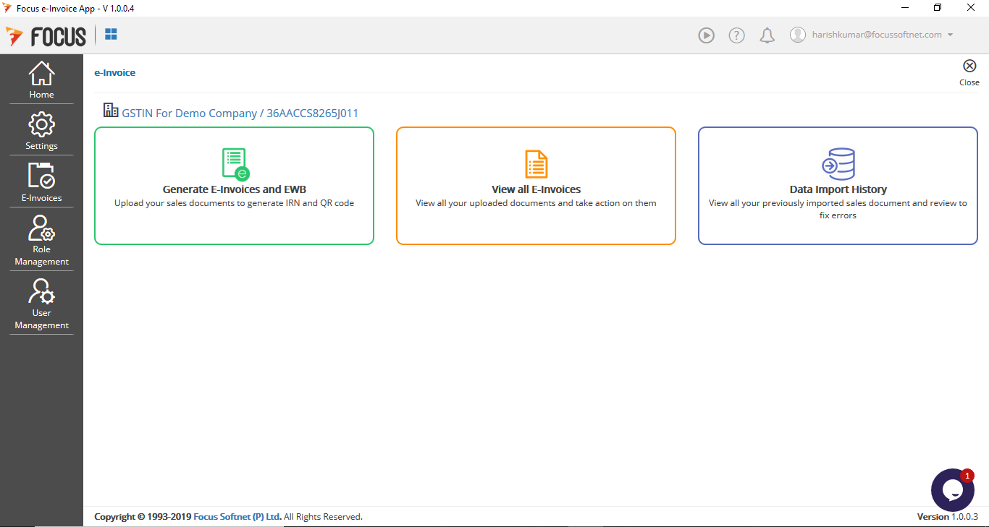

## Generate E-Invoices Tile

* To generate E-Invoices, click on ‘Generate E-Invoice and EWB’ tile
* For ‘Auto’ Generation Mode, the application will search for a new file in the location set in the ‘File from’ section and generate E-Invoices as per settings in Preferences.
* For ‘Manual’ Generation Mode, the application will search for new file in the location set in the ‘File from’ section and generate E-Invoices for files available in the location. If user has not set a ‘File From’ location in ‘Preferences’ the application will prompt for location everytime the user clicks on this tile.

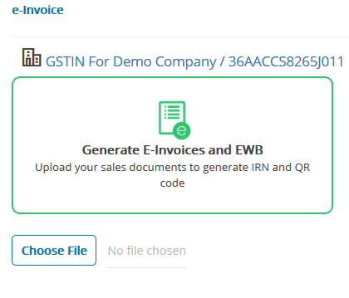

### Imported Data Review

The details in the input file are verified for validations and focus will display the ‘Imported Data Review’

Within this display screen are the following tabs

#### ‘Valid Invoices’ Tab

Invoices in the file which are Valid completely are shown in the ‘Valid Invoices’ Tab

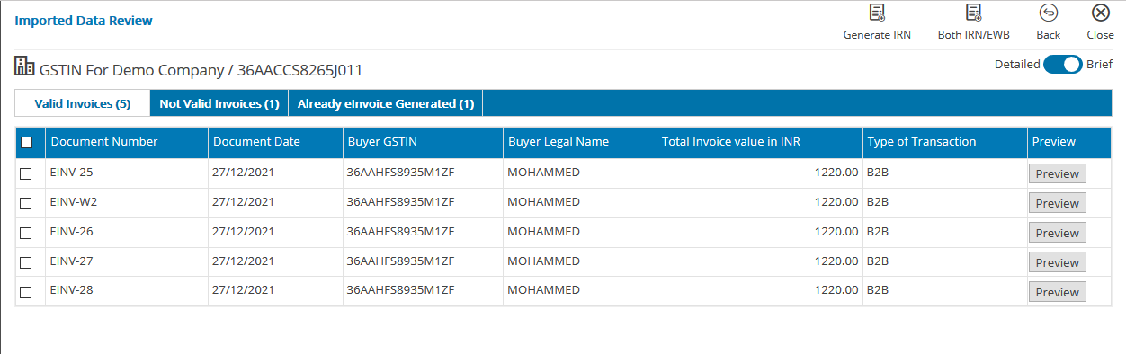

User can select individual invoices in the grid and Click on ‘Generate IRN’ button or ‘Both IRN/EWB’ button to generate only E-Invoices or both E-Invoices and E-Way Bills for the selected Valid Invoices

A Success Message will be displayed on the screen as shown below on successful generation of the E-Invoices

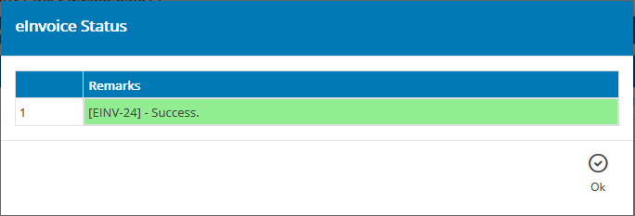

#### ‘Not Valid Invoices’ Tab

Invoices in the file which are not completely Valid are shown in the ‘Not Valid Invoices’ Tab

Errors in each of the invoices which are in this tab can be seen by clicking on the ‘….’ button in the Error column against the row of the invoice.

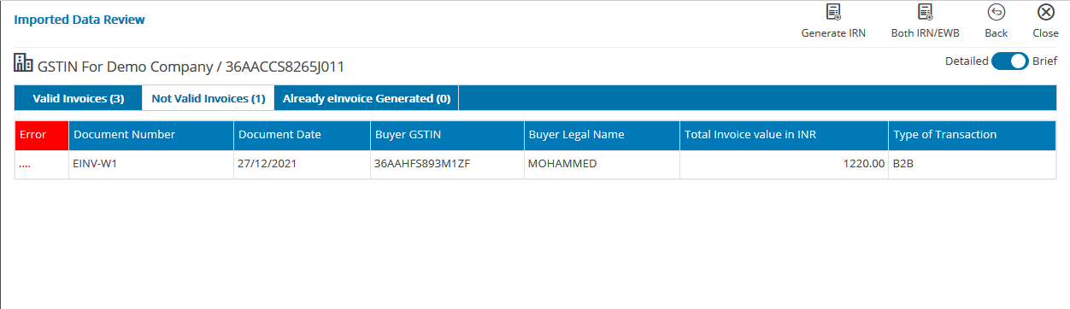

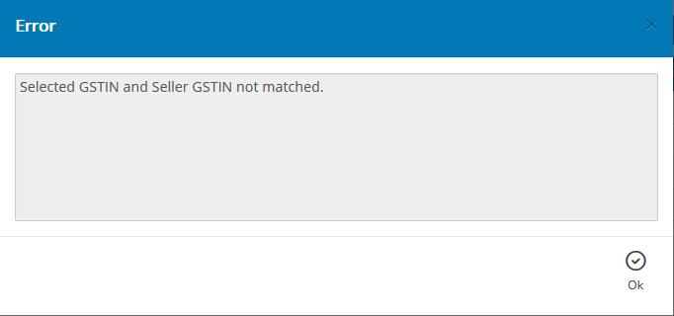

##### Proposed Action:

Based on the Errors specified for an invoice, the User can make corrections for these vouchers and retry to generate E-Invoices

**Additional Information:**

The invoices will be classified into these tables based on the entries which will be validated based on the current validations set by GSTN at the time of registering the E-Invoice. As these may be subject to changes over time, the same are not included in this document. Users to provide valid entries as per formats updated by GSTN from time to time.

#### ‘Already E-Invoice generated’ Tab

Invoices in the file for which E-Invoices were already generated are shown in the ‘Already E-Invoice generated’ Tab

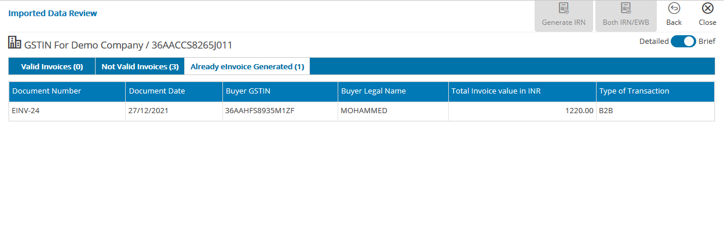

### View All Invoices Tile

#### Viewing an E-Invoice/Eway Bill Generated

To view the E-Invoices generated, click on ‘view all E-Invoices’ tile. This screen will display the list of all the invoices for which E-Invoices were generated.

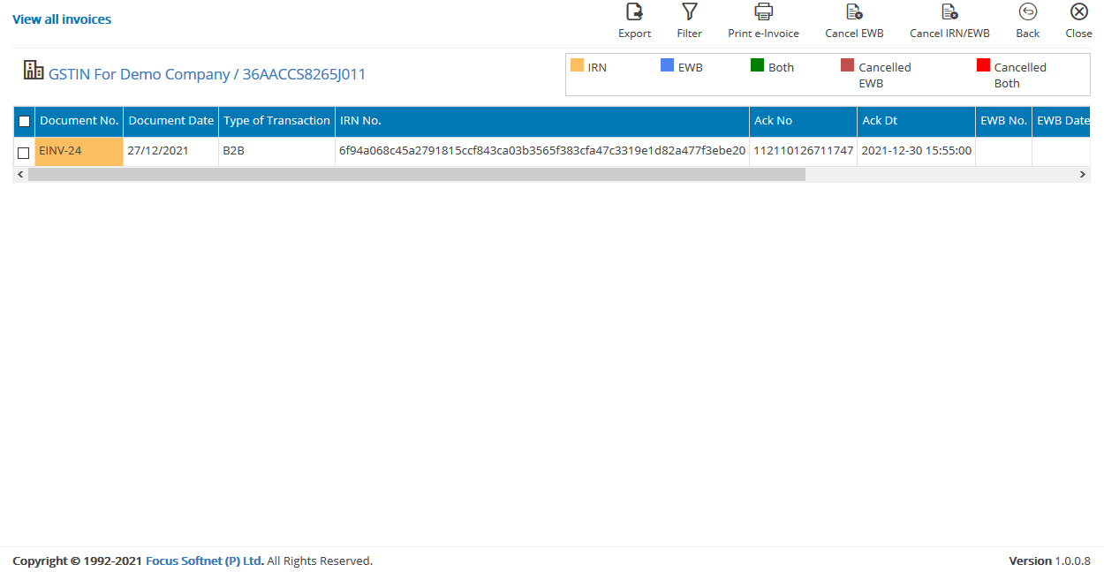

#### Cancelling an E-Invoice/EWay Bill

User can select these individually and click on ‘Cancel EWB’ or ‘Cancel IRN/EWB’ buttons for cancelling only the EWay Bill or both the EWay Bill and E-Invoice for the selected invoice.

Note: An E-Invoice can be cancelled within 24 hours of generation of an E-Invoice only

#### Printing an E-Invoice/EWay Bill

User can select invoices in this grid and click on ‘Print E-Invoice’ button to print the selected invoice.

#### Export to Excel

Click on ‘Export’ to export the details in the grid in Excel format to an external location.

## Validations

### Validations for E-Invoices

1. E-Invoice request JSON data will be validated as per the E-Invoice JSON Schema given in the notification.
2. The attributes in the JSON schema have been defined with column length, format and data types. Where-ever the data format is not defined for the attribute having data type as string, then for these attributes, the alphanumeric and special characters are allowed except the special characters “ (double quote) and \ (back slash).
3. IRN generation is allowed only for the active Supplier. If he is cancelled or suspended, he cannot generate IRN.
4. The following fields should have one of the values given in the master codes.
   1. Supply Type of Transaction
   2. Document Type
5. The category of transaction of "Business to Consumer (B2C)" invoices will not be considered and hence the API interface should not request for IRN for these transactions.
6. Document number should not be starting with 0, / and -. If so, then request is rejected.
7. IRN requests with Document Date from 01/10/2020 only will be accepted and processed for IRN generation. IRN requests belonging to previous dates will be rejected.
8. Supplier should ensure that the unique invoice number is being generated for the financial year for each invoice, in his ERP/manual system. The financial year is derived from the date of invoice. The financial year starts from 1st April and ends on 31st March.
9. Duplicate IRN requests are not considered. That is, if the IRN is already generated on particular type of document and document number of the supplier for the financial year, then one more IRN cannot be generated on the same combination.
10. E-Invoice(IRN) cannot be re-generated for the cancelled E-Invoice(IRN) also.
11. Request for the IRN/E-Invoice can be made only by the supplier of the goods or services.
12. In case of e-commerce transactions, the e-Commerce Operator can request for the IRN/E-Invoice on behalf of the supplier. In this case, the e-Commerce Operator should have been registered on the GST portal as e-Commerce Operator and pass eCom_GSTIN accordingly.
13. In case the supplier is SEZ unit, then he cannot generate E-Invoice.
14. "Reverse Charges" can be set as "Y" in case of B2B and SEZ invoices only and tax is being paid in reverse manner as per rule. Even in case of Reverse Charged invoices, the Supplier has to generate the IRN.
15. SEZWP and SEZWOP supply type is allowed only if the taxpayer type of recipient GSTIN is ‘SEZ Unit’ or ‘SEZ Developer’.
16. Recipient GSTIN should be registered and active or suspended, on the date of preparation of the document by the supplier.
17. In case Recipient GSTIN is cancelled, then the document date should be between the date of registration and date of de-registration of the Recipient GSTIN.
18. In case SEZ Developer is Supplier, then only IGST tax rates are applicable irrespective of Supplier state code and POS code.
19. In case of transaction of direct export, recipient GSTIN has to be URP and state code has to be 96, PIN code should be 999999, POS should be 96.
20. In case of GSTIN of supplier or recipient belonging to state of ‘OTHER TERRITORY’ (with state code as 97), then PIN code can be 999999.
21. First two digits of the Supplier / Recipient GSTIN should match with the state code passed in the Supplier / Recipient details accordingly except if supply type is exports wherein Recipient state code will be 96.
22. PIN Codes are validated against the States, they belong by matching the complete pincode against state master. If the PIN Code does not exist in the master database of the e-invoicing system, and the first 3 digits of the PIN code is matched with the State as per the pattern of PIN code-to-State mapping defined by postal department, then IRN gets generated.
23. If "Shipping party" is provided, then the transaction is considered as "Bill To-Ship To".
24. If "Dispatching party" is provided, then the transaction is considered as "Bill From " Dispatch From".
25. If both Shipping and Dispatching parties are provided, then the transaction is considered as "Combination of Both" (Bill From - Dispatch From and Bill To- Ship To).
26. In case of export transactions for goods, if e-way bill is required along with IRN, then the 'Ship-To' address should be of the place/port in India from where the goods are being exported. Otherwise E-way bill can be generated later based on IRN, by passing the 'Ship-To' address as the place/port address of India from where the goods are being exported .
27. In case IGST on intrastate supply, tax rates and tax values related to IGST should be passed, and Supplier state code and POS state code should be same.
28. In case IGST on intrastate supply, then Reverse charge is mandatory.
29. The state code of the Supplier GSTIN and POS will decide whether the supply type is Interstate or Intrastate. That is, if the State code of Supplier and POS is same, then it is intra-state, otherwise it is inter-state. However, IGST on intrastate supply attribute will overrule this condition.
30. In case of Exports and SEZ, the supply is always Interstate
31. JSON payload size cannot exceed 2MB.

### ****Validations on Items:****

1. Serial number of the item can be only numeric & is verified for duplicate values.
2. Each item needs to have valid HSN code with at least 4 digits. HSN Code should be valid as per the GST master.
3. If Is Service is selected, then the HSN codes must belong to services.
4. Each item should have valid Unit Quantity Code (UQC) as per the master codes, in case of goods.
5. Quantity and Unit Quantity Code are mandatory for Goods and optional for Services.
6. Tax rates are being validated. Only the allowed tax rates will be accepted for all types of document including Credit Note and Debit Note. In case of intra-state transaction, the sum of SGST and CGST tax rates should be entered as GST Rate.
7. In case of inter-state transaction, the IGST tax rate and value has to be passed.
8. In case of export transaction, IGST tax rate and value has to be passed.
9. In case the Recipient is SEZ unit or SEZ Developer, then IGST tax rate and value has to be passed irrespective of state of the Recipient.
10. Maximum number of items in each invoice should not exceed more than 1000 items and a minimum of 1 item should be available.

### ****Calculation of Values:****

1. The following summation validations are to be done for items
   * Taxable Value of Item = Gross Amount of Item - Discount
   * SGST Value of Item = Taxable Value of Item X GST Rate / 2, if intra-state CGST Value of Item = Taxable Value of Item X GST Rate / 2, if intra-state
   * IGST Value of Item = Taxable Value of Item X GST Rate, if inter-state
   * Cess Value of Item = Taxable Value of Item X Cess Rate
   * State Cess Value of Item = Taxable Value of Item X State Cess Rate
   * Total Value of Item = Taxable Value of Item + SGST Value of Item + CGST Value of Item + IGST Value of Item + Cess Value of Item + State Cess Value of Item + Non-Advol Cess Value of Item + State Cess Non-advol value of Item + Other charges.
   * However, in case of Reverse charge and Export transactions (EXPWP), Total value of Item can match with either with tax values or without tax values. That is, the total value of item can include or exclude the tax values as per the business requirements.
   * (Note: Temporarily, the validation of 'Gross Amount of Item with Quantity and Selling Unit Price' has been withdrawn.
   * In case of EXPWOP and SEZWOP, Passed IGST Value of Item will not be validated even if actual tax rate is passed, if the passed value of IGST for that is ZERO.)
2. The following summation validations are to be done on Invoice total
   * Total Taxable Value = Taxable Value of all Items
   * Total SGST Value = SGST Value of all Items
   * Total CGST Value = CGST Value of all Items
   * Total IGST Value = IGST Value of all Items
   * Total Cess Value = Cess Value of all Items + Non-Advol Cess Value of all Items
   * Total State Cess Value = State Cess Value of all Items + State Cess Non-advol Value of all Items
   * In case of CREDIT NOTE AND DEBIT NOTE, the ‘IGST/CGST/SGST/CESS value of item’ is not validated with corresponding tax rates and taxable values.
3. Tolerance limit for points 1 and 2 above: The passed value should be between minimum and maximum values as explained here. Minimum value is considered as the rupee part of the calculated value minus one rupee and maximum value is taken as the rounded up to next rupee value of the calculated value plus one rupee.
   * Example 1: In Point 1 and 2, if calculated value for IGST of item A is 2345.04 then tolerance limit for passed value of that item is between 2344.00 and 2347.00.
   * Example 2: In Point 1 and 2, if calculated value of IGST of all items is 10241.00 then tolerance limit for passed value of IGST of all items is between 10240.00and 10242.00
4. The round-off value for 'Round_off_amount' attribute is to adjust final 'Total_Invoice_Value_INR' attribute and can be between -99.99 and +99.99
5. The following summation validation is to be done on Invoice total
   * Total Invoice Value = Sum of All Total Value of Items - Invoice Discount + Invoice Other charges + Round-off amount
6. Tolerance limit for point 5 above: The passed value should be between minimum and maximum values as explained here. Minimum value is considered as the rupee part of the calculated value minus one rupee and maximum value is taken as the rounded up to next rupee value of the calculated value plus one rupee.
   * Example : If ‘calculated total invoice value’ is 10241.61 then tolerance limit for ‘passed total invoice value’ is between 10240.00 and 10243.00

##### ****Validations on e-waybill:****

1. E-waybill can be generated only if E-way Bill related details are passed where distance is mandatory.
2. E-way Bill is not generated for document types of Debit Note and Credit Note and Services.
3. E Way Bill can be generated provided at least HSN of one item belongs to goods.
4. If only Transporter Id is provided, then only Part-A is generated. Transport Mode, Vehicle Type, Vehicle No, Transportation document number and date should be null or attributes should not have been passed.
5. If mode of transportation is "Road", then the Vehicle number and vehicle type should be passed. If mode of transportation is Air, Rail, then the transport document number and date should be passed. Vehicle type and vehicle number should be null or attributes should not have been passed.
6. If mode of transportation is “Ship/ Road cum Ship”, then either Vehicle number or transport document number and date or both can be passed. Vehicle type should be ODC.
7. The Vehicle no. should match with specified format and exist in Vahan database.
8. E-Waybill will not be generated if the Supplier or Recipient GSTIN is blocked due to non-filing of Returns.
9. Pincode of Recipient GSTIN is mandatory if Ship-To details are not entered.
10. The distance of transportation is validated against the auto-calculated PIN-PIN distance stored in the system. The allowed distance for transportation should be between +/- 10 % of auto-calculated PIN-PIN distance. If the auto-calculated distance is less than 100 KMs, then The allowed distance for transportation should be between 1 and +10 % of auto-calculated PIN-PIN distance.
11. If the distance of transportation is passed as 0 (zero), then the system will consider it as request made by the tax payer, to consider the auto-calculated PIN-PIN distance for the generation of e-way bill and generate the e-way bill along with IRN. The actual distance is passed in “Info. Message” column for reference.
12. If the PIN-PIN distance is not available in the system, the passed value of distance will be taken for generation of e-way bill and distance value can not be more than 4000.
13. The actual distance has to be passed in case the source and destination PIN codes are same and the allowed range of value is from 1 to 100.
14. In case of export of goods, if e-way bill has to be generated, then the address of port should have been passed as shipping address during generation of IRN.
15. In case incomplete information has been passed for generation of E Way Bill, then IRN will be generated and returned but not E Way Bill number. However subsequently, based on IRN, E Way Bill can be generated.

## Data Import History Tile

Click on ‘Data Import History’ tile to view all previously imported sales document and review to fix errors

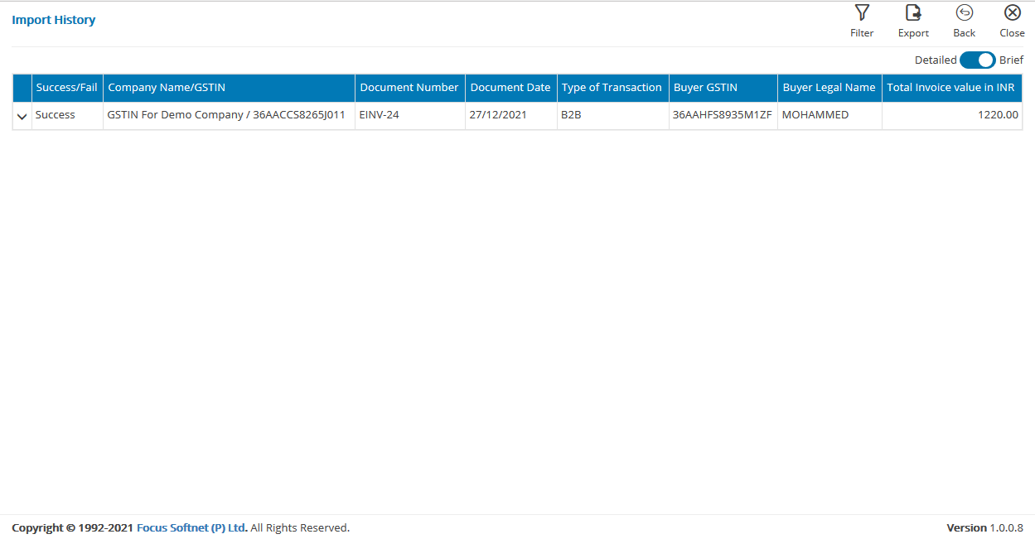  
Note: In the E-Invoices Menu, the details of the invoices in the grid can be of all fields or few important fields by toggling between the ‘Detailed’ and ‘Brief’ button.

# Role Management Menu

This menu is used to manage the different user roles in the application

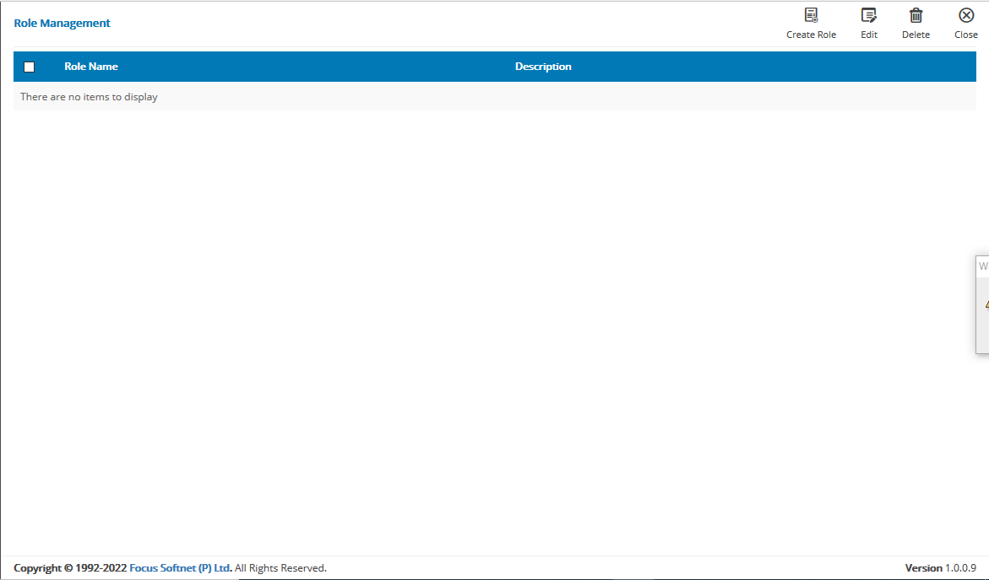

## Creating a Role

* Click on the ‘Create Role’ button to create a Role

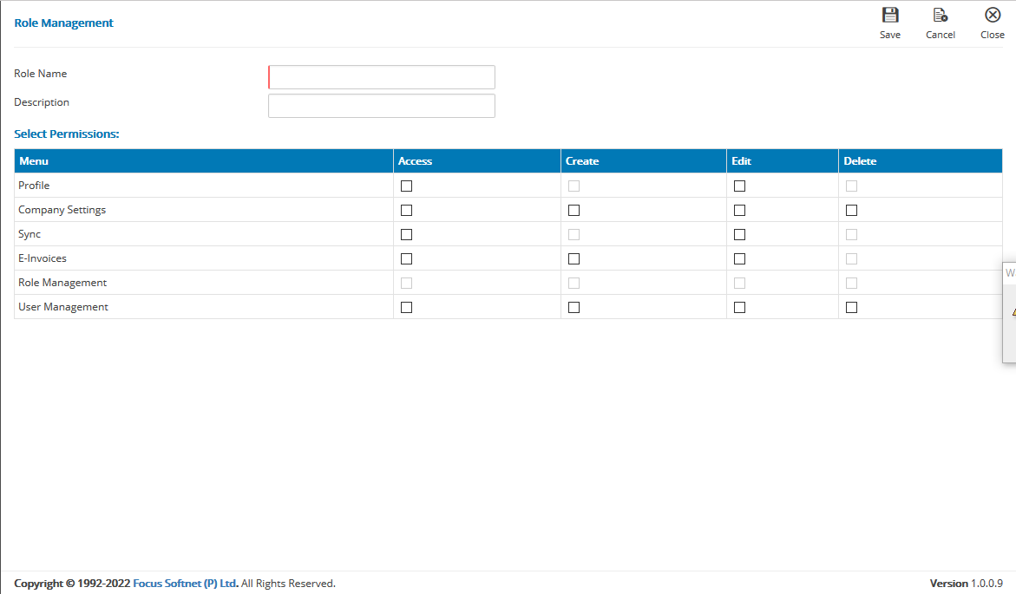

* Provide Role Name and description
* Set permissions for the role by selecting the checkboxes against each permission, as required.
* Click on ‘Save’ to save entries.

## Editing Roles

To make changes to an existing role

* Select the role
* Click on ‘Edit
* Make necessary changes
* Click on ‘Save’

# User Management

This menu is used to manage the different user IDs in the application

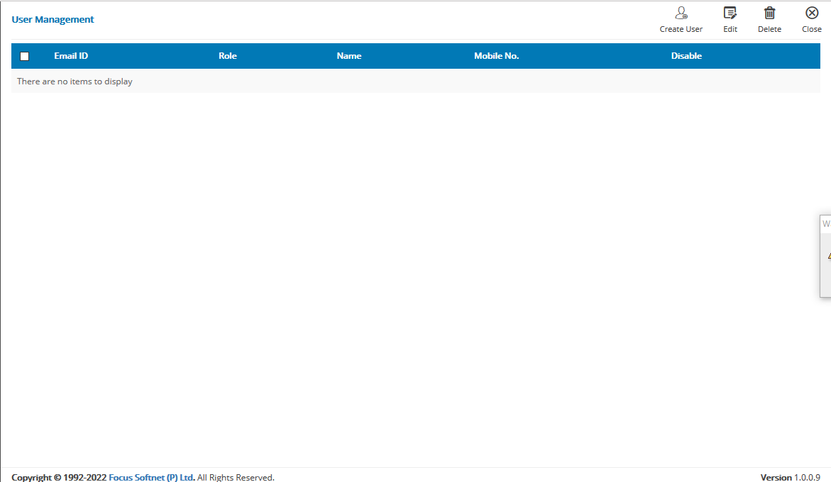

## User Creation

* Click on the ‘Create User’ button to create a new user
* Provide entries in Email ID, select role, password, Confirm Password, Name and Mobile Number fields.
* Click on ‘Save’ to save entries.

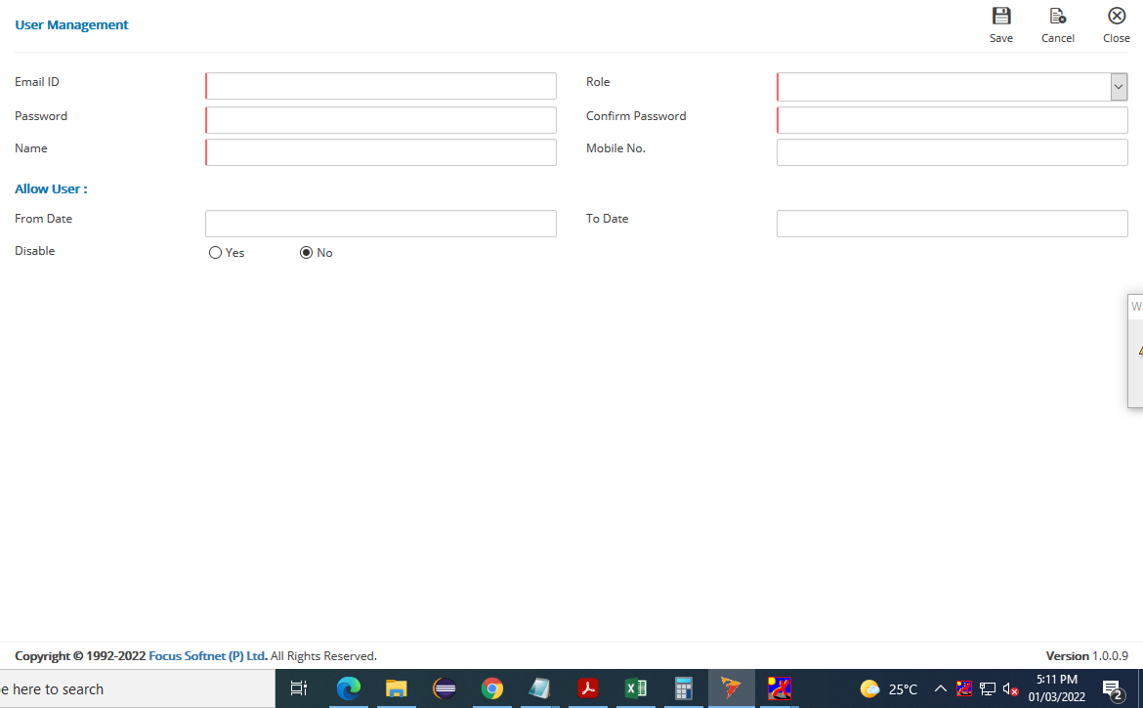

* Users can be created with access permissions only for a specified time by using the From Date and To date fields.

## Disabling User

To disable Users who will no longer be required to access the application, the ‘Disable? Yes/No’ radio buttons are provided. Users can be defined disables or enabled as and when required.

## Editing User

To edit user permissions, select the user ID and click on ‘Edit

Make changes and save entries to effect.